DEPARTMENT OF COMPUTER SCIENCE

Name : Muhammad Yasir Raza

Reg. Id : 4105

Course : Database Management System

Faculty : Muhammad Zulqarnain Siddiqui

Patient-Info (Queries):

SELECT Patient_Name, Patient_Disease

FROM ['Patient-Info'];

Output:

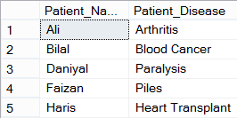

Patient-Info (Queries):

SELECT *

FROM ['Patient-Info']

WHERE Blood_ID='A+';

Output:



Donor Info (Queries):

SELECT DonorName

FROM ['Donor-Info'];

Output:

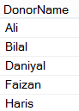

Donor Info (Queries):

SELECT Donor_Disease

FROM ['Donor-Info']

where Donor_Disease='none';

Output:

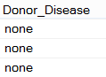

Blood Bank Info (Queries):

SELECT DistributionNetwork

FROM Blood-Bank-Info

where DistributionNetwork='SC-II';

Output:



Blood Bank Info (Queries):

SELECT ConsumerHospital

FROM Blood-Bank-Info

Where ConsumerHospital='AghaKhan';

Output:



Blood Group Info (Queries):

select BloodGroupName

from ['Blood-Group-Info$']

where Quantity>2;

Output:

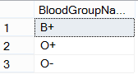

Blood Group Info (Queries):

select BloodGroupName

from ['Blood-Group-Info$']

where Quantity>2 AND Quantity<4;

Output:



Blood Bank Staff Info (Queries):

SELECT * FROM ['Blood-Bank-Staff-Info$']

WHERE Staff_StartingTime BETWEEN 9 AND 17;

Output:

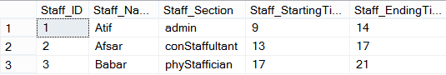

Blood Bank Staff Info (Queries):

SELECT *

FROM ['Blood-Bank-Staff-Info$']

full JOIN

['Blood-Group-Info$']

ON ['Blood-Bank-Staff-Info$'].Staff_Name=['Blood-Group-Info$'].BloodGroupName;

Output:

